Relief Cycle
I created four high reliefs that are inserted into the pedestal at eye level. They cover the Roman Catholic, Protestant, Judaic and Islamic religions. Consequently, Saint Noshame appears in different roles in each narrative. It was important to illustrate that religion is not impervious to this social disorder.
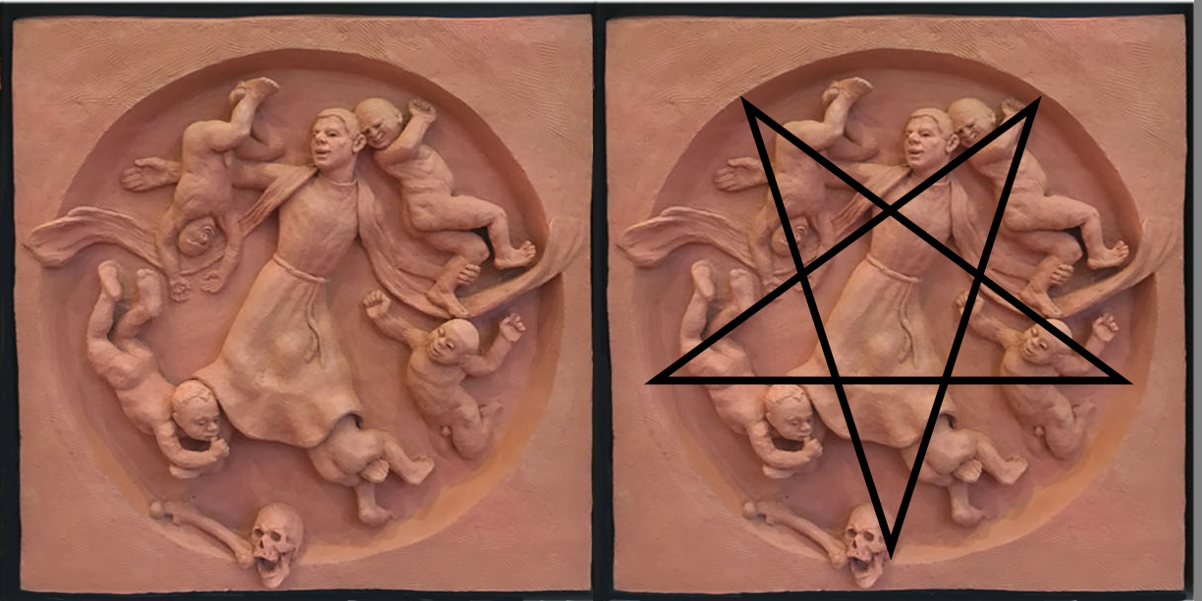

Pentagram
This is the first relief and represents Roman Catholicism. The main structural compositional points create an inverted five-pointed star that is a symbol for Devil worship, the opposite of what religious principles represent. Here I am subverting traditional iconography. The cherubs are hardly innocent and are accomplices. One sucks his thumb in a suggestive gesture, another is under the robe, a third is showing his hardware to the priest whose attributes are in his line of vision, another is whispering in his ear and the last has a face of a teamster. The femur and skull that form the point of the inverted star, anchoring the composition, is common symbol in crucifixion paintings, but here, is suggestive of fellatio.

